**Maintenance Plan**

**Outline**

1. Maintaining a Platform
2. Hiring Developers
3. Resources
4. Protecting the Brand
5. Initial Cash Flow
6. Conclusion

**Owners**

Denae Douglas

Luciano Fasani

Brock Sauvage

**Maintaining a Platform**

This game can be hosted on several different platforms, but a web based game, Steam Greenlight and Xbox Live will be examined. A website can be easily maintained for about $25 dollars. Amazon offers a wide variety of pay-as-you-go services and resources that allow game developers to deploy code and pay for builds right up to the very minute the build is terminated. This option is extremely easy on costs. However, getting the game out into the gamer arena would be difficult because we would have no gaming platform to help advertise the game.

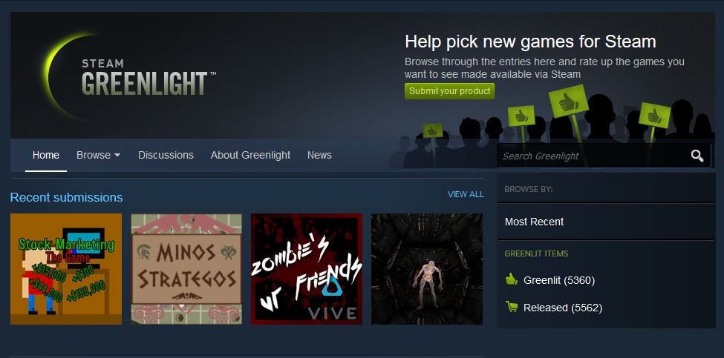 Another option is Steam Greenlight. This is a platform where game developers can submit their game for consideration on Steam. The developers post a video of gameplay, screenshots, a logo, and a written description of the game. The cost is a one-time $100 submission fee. The benefit of this option is that game developers can get a feel for how their product will be received amongst other gamers and receive feedback about the overall structure of their game. Also, the game has the potential to be selected to be hosted on Steam. Steam Greenlight has a lot of pros for game developers. You can submit mods of games, free games, and games that are still in development. If your game gets Greenlit, Steam reaches out to the developers and establishes a timeline for when that game will be hosted on Steam. On the other hand, a downside to Steam is that if your game is web based, Steam will not accept the submission. It must be able to run as a stand-alone application without the use of a browser. Overall, Steam Greenlight is a great option that is still cheap.

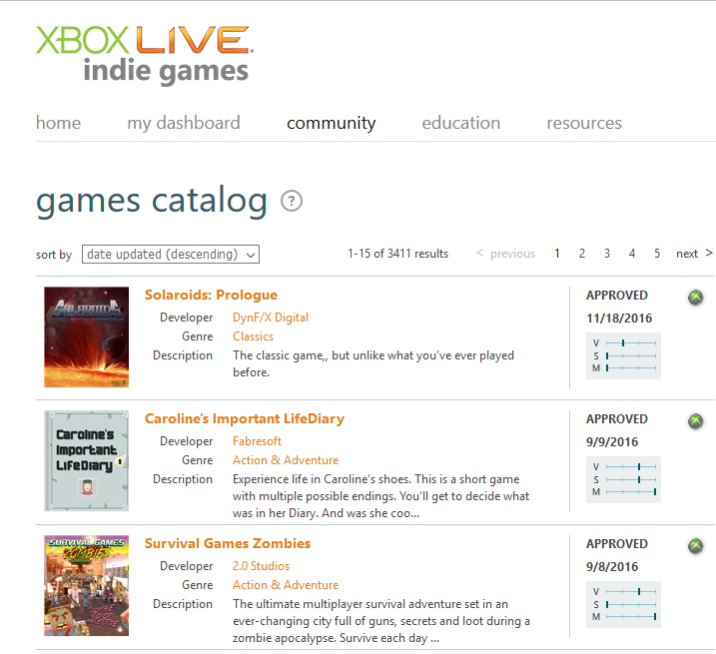 Lastly, Xbox Live Indie Games could be used to host the game. This is also a relatively cheap option, but it is a reoccurring cost. A yearly subscription price of $99 is charged, and the developer can host up to 20 games. Developers can maintain and improve their game using their Xbox console with XNA Game Studio Connect. One could also customize their game for specific regions and languages, and get peer reviews on other indie games before their release. Some advantages of Xbox live are a free membership to Xbox Live Indie Games for DreamSpark members, submit updates to your game at no costs, and price modularity. Some disadvantages to this approach are that the game must be less than 500MB, members under 17 cannot submit games, and the developers are paid 70% of the revenue accrued from the game. In addition, the game must garner $150 in sales before payment begins.

With these options, our game has the potential to be viewed by millions of users for a very reasonable price.

**Hiring Developers**

The salaries for game developers varies widely across the board. Certain influences are region, gaming company, and the overall skill set of the developer. Since this game is a 2D Platformer, there won’t be a lot of extra developing going on past the initial stage of design. However, there are some bug fixes and optimizations that could be made, as well as new level additions. Glassdoor puts that salary average for game developers between $65k and $75k. However, game developers can attain salaries as high as $100k.

Some benefits to hiring developers (designers are included as well) is that you have a special set of expertise that can push the game forward and mold it into something bigger. Developers and designers take the ideas of the hirer, and bring them to life. However, Techcrunch.com says that a common issue between the designer and hirer relationship is misalignment. The team wants something and doesn’t know the cost of getting it. The developer must effectively communicate the path and plan for a game. In addition to the vision for the game, often creative ownership also becomes an issue. Does the team say where to go, or does the designer pick? Hiring the right fit for your team is key to creating a good game design. Techcrunch.com also suggests bringing a potential hire in to work on an iteration or two just to see where they would take the game if given the job. Ask to see some of their work to see if what they do is really what you want. Lastly, ask questions. Make sure you really understand everything they are saying so that you know what you’re in for.

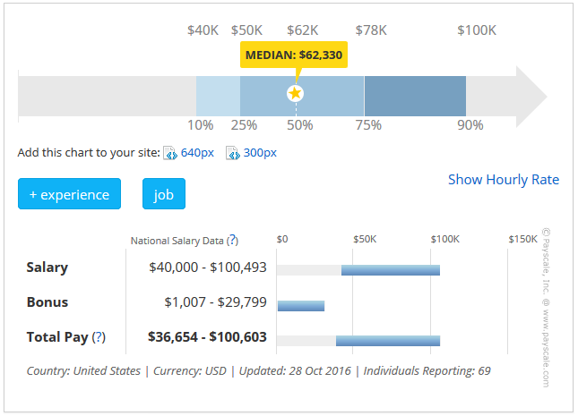

**Resources**

Resources are a huge part of any company that is developing anything. Each employee must have the proper tools to do their job effectively and carry out the day-to-day tasks required of them. For this game, some of the major resources that were used were Unity, Github, Pyxel Edit, documentation, and the internet. However, if the game were to continue to be developed, it would not be limited to just these few. Updated graphics may require better software such as Adobe Photoshop. The company may need to hire game artists and graphic designers to reach visual goals. A more suitable source of version control may be required to support the overall size of the game. We may need to upgrade to new versions of our game developing tools such as Unity to advance the game. Our current costs are very low. We are currently using the free version of Unity, Github is also free, and our graphic software was $9.00. However, if we were to upgrade to more advanced tools, a Unity subscription would cost anywhere from $25 - $125 dollars per month. Also, as mentioned earlier, Amazon offers a variety of services to store and deploy your code with a pay-as-you-go setup. An Adobe Photoshop license would be $19.99 per month which comes to roughly $240.00 per year. It is evident that upgrades come with a natural increase in price. Furthermore, all the expenses incurred will be ongoing expenses for the life of the company. Below are some side by side comparisons of prices and upgrades.

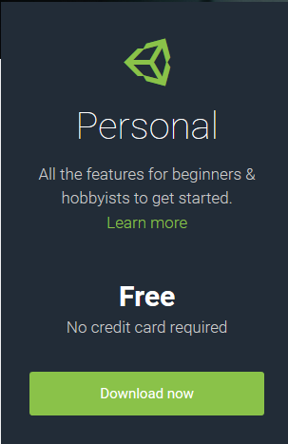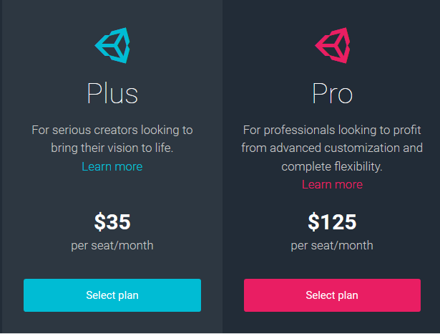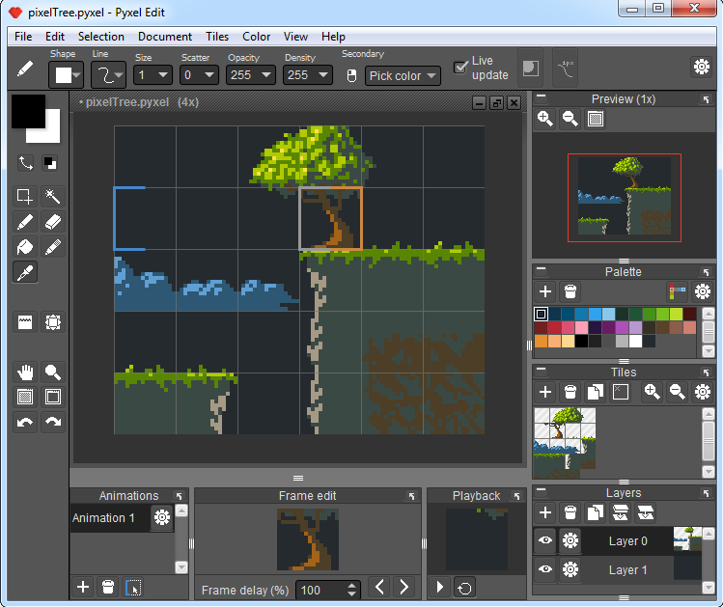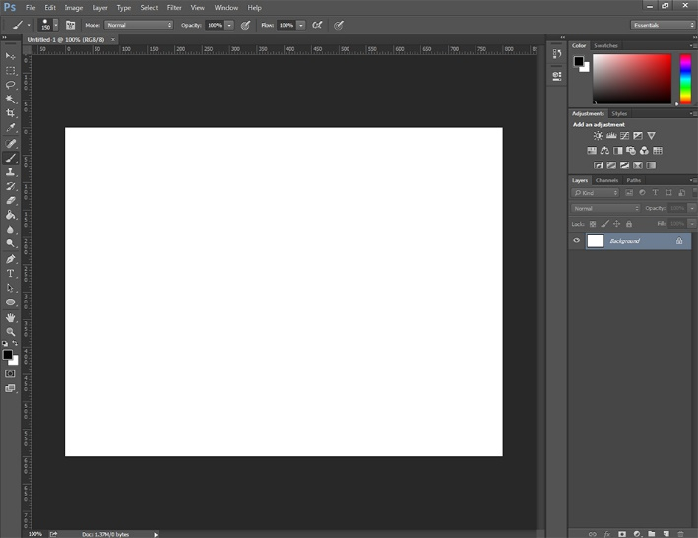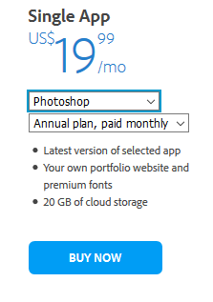

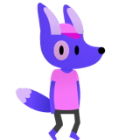**Protecting the Brand**

In addition to resources and costs of the company, protecting the game under the law must be maintained as well. Under copyright law, the work prepared in this project is copyrighted and our team reserves the right to distribute, make derivative works, perform, and display it publicly (though KU does have rights). This comes at no cost to us as developers and ensures the protection of our ideas, code, and design. Also, our team may want to trademark a special logo or design feature that marks our game such as the main character.

**Initial Cash Flow**

As mentioned earlier, our team only spent $9 dollars and time to build this project. We relied on documentation, the internet, and our own skills as programmers to create it. However, if we are going to maintain the project for the next year and hire other developers and designers, we are going to need some initial cash flow to cover the cost of expenses and keeping those developers employed. An initial seed may need to be planted to get the development off the ground. If we employ 2 -3 more developers, equip them with all the necessary resources and tools they need to continue the project, and pay them a starting salary of $65k, we would probably spend somewhere between $175k -$200k. This money only covers the cost of hiring 2 – 3 employees and making sure each of them has Unity and or Photoshop to work with. This cost doesn’t include making sure the initial design/development team is paid and the cost of hosting the game somewhere like Xbox Live Indie Games or Steam. If we add in those numbers, the cost goes to something more like $400k - $450k. Compared to the upkeep of major games (millions of dollars), this is still extremely cheap.

Discussed above is the money flowing out. We will also need to maintain the money that comes into the business should the game be publicly available for purchase. This has to do more with how we work with the hosts of our game to settle the amounts paid to us and the amount the host keeps for providing their services. For Xbox Live, developers are paid 70% of the revenue. Similarly, Steam takes somewhere between 30 – 40% of the sales in the Steam store. Setting up a bank account for storing revenue and having a small cash box for roughly two months of expenses is also a good practice to keep.

**Conclusion**

In conclusion, the year-long continuation and maintenance of our game would be relatively simple. As a sequential plan, we would find a host for the game, bring our initial seed money to the table, hire the necessary personnel for the job, and purchase resources and tools. We’ve estimated that the final costs for all of this would be around $450k.